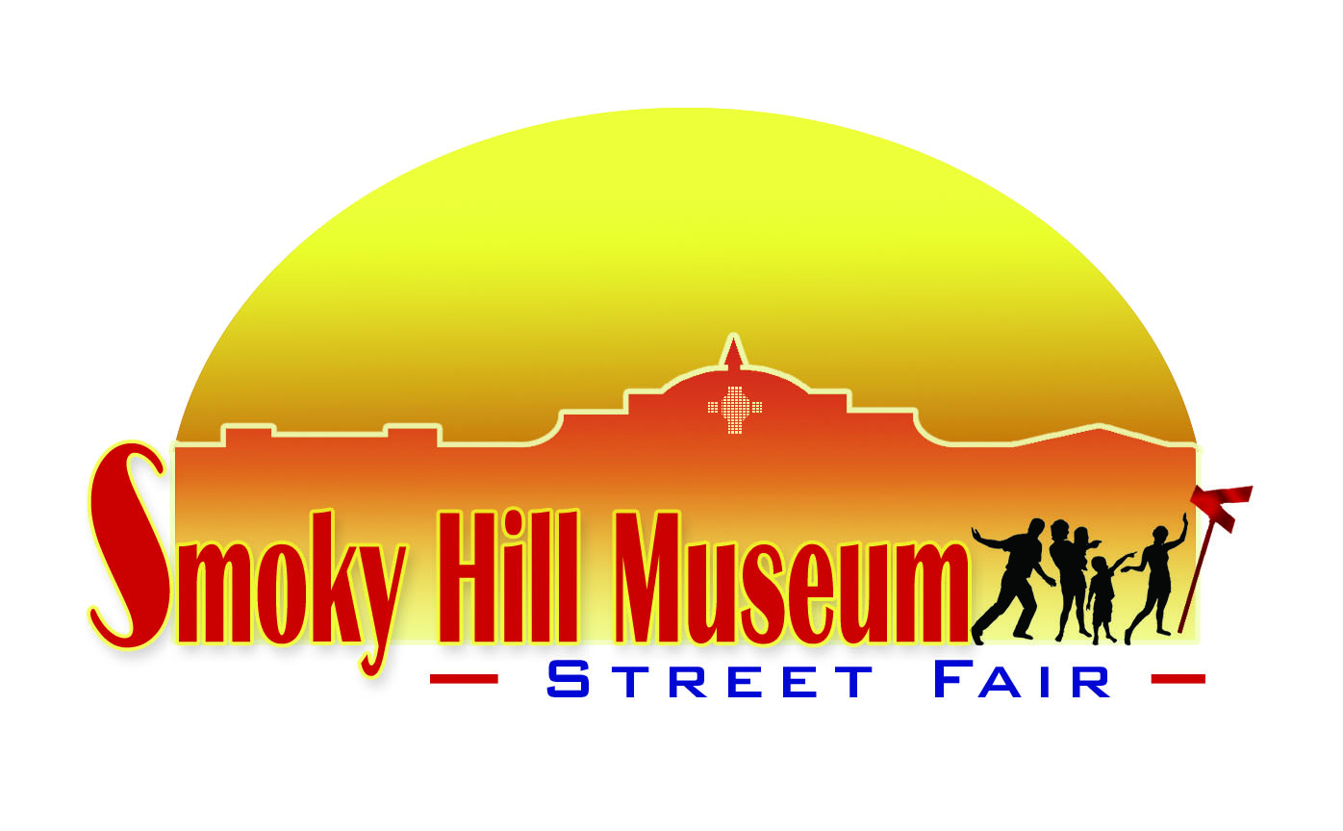

# To: Parade Participants

From: Rosa De la Cruz, Smoky Hill Museum

RE: Smoky Hill Museum Street Fair –Saturday, September 25, 2021

Greetings from the Smoky Hill Museum!

It’s time to make plans for a great parade at the Smoky Hill Museum Street Fair 2021. This is a one-day event of fun celebrating the history and heritage of the Smoky Hills region.

The Smoky Hill Museum is seeking parade entries and invites you to participate in this wonderful event. The quality and variety of entries play an important role in the Street Fair’s popularity. In 2019 parade was attended by almost 3,500 people. We hope you return the parade application and join in the fun!

Decorated entries are highly encouraged. This year’s Smoky Hill Museum Street Fair Parade will feature an autumn or Old West theme. Please follow one of these themes as much as possible.

We have worked with the Salina Police Department to plan a safe and enjoyable parade. The parade route will be on Santa Fe between Elm and the Masonic Temple.

**Parade applications must be returned by Friday, September 3 in order to participate.**  You may use the application form on our website <https://www.smokyhillmuseum.org/street-fair/street_fair_parade.html>. An information packet will be sent on September 10 to all entries received by September 3. On September 25, the parade entry sign-in will begin at 9:00 a.m. Participants must be signed in and in place by 9:45 a.m. The parade will begin **promptly** at 10:00 a.m.

Thank you for your participation in this festival of fun. If you have any questions, please call me at the Smoky Hill Museum, 785-833-8021 or email me at rosa.delacruz@salina.org. I look forward to seeing you at the parade!

Sincerely,

*Rosa De La Cruz*

211 West Iron Avenue • PO Box 101 • Salina, Kansas 67402-0101 • Tel 785.309.5776 • Fax 785-826-7414 • www.smokyhillmuseum.org

*A Division of the Salina Arts and Humanities • A Department of the City of Salina*