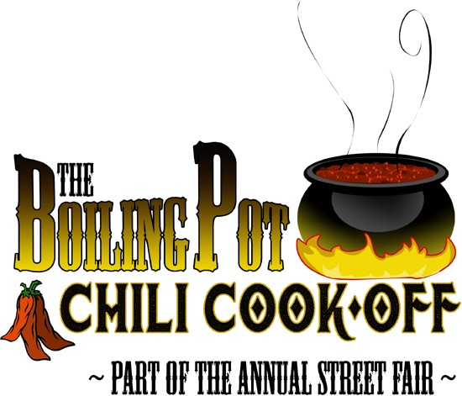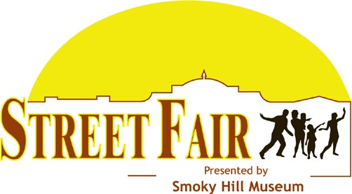

Time to get cooking!

With last year’s cancelling of Street Fair due to Covid 19, Salinan’s are ready for some good chili. That’s where you come in. In order to make this happen, we need the talent of local teams to cook up their own unique brand of chili. This is a fun day to come out and enjoy the weather as we usher in the fall season. In order to make this less of a burden on our teams, we help provide ingredients to help each team off to a good start. Teams will receive a generous starting kit of ingredients that includes 15 lbs. of beef and a mess of onions and tomatoes. From there, each team can add their own unique ingredients to make the chili something special.

So why should you enter? The answer in our eyes is pretty simple. One, you become an active part of the community making our city great, while at the same time promoting your organization or business. Two, you help support the museum which provides great events, exhibits and presentations year around for FREE! Lastly, it’s just plain fun. Not only could you win bragging rights but also some great prizes.

We look forward to seeing you at the 2021 Boiling Pot Chili Cook-Off. Entering is easy. Follow this simple check list.

- Create a team with up to four people
- Fill out and return the enclosed form
- Choose a theme for your booth, and yes, it’s ok if you want to highlight your organization through your booth theme
- Create your recipe and be ready for a day of fun

Following the public sampling and judging, a winner will be announced on the main stage.

If you still have questions or need assistance, contact Rosa or Josh, (785) 309-5776. We are here to help you have a great time competing. Again, thank you for helping make this a great event!

Joshua Morris Rosa DelaCruz

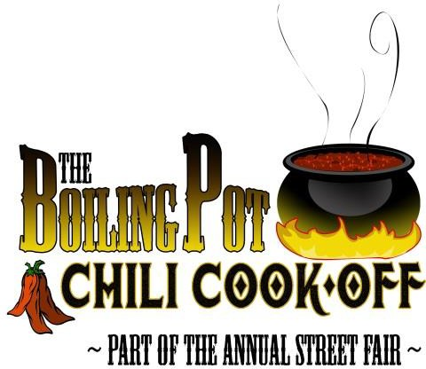

September 25th • Load in begins at 6 am and must be complete by 8 am • Public serving begins at noon.

Team Name:

Team Captain:

Mailing address:

Email:

Phone: Cell:

Application fee: $25 payable to The Friends of Smoky Hill Museum.

ENTRY FORMS DUE BY AUGUST 31.
Each team will be provided with a set of starting ingredients listed below. Additional ingredients will be required to make your chili unique. A team may wish to pass on the provided ingredients, but the museum will not provide alternate options from those stated below. Following the public sampling and voting period, a winner will be announced on the main stage. Proceeds from the competition will go towards the Smoky Hill Museum to maintain year around events, exhibits and presentations free to the public.
You are responsible for: 10 x10 pop-up canopy, water, propane, hand & ware washing and fire extinguisher.

We will provide the following: 15 lbs beef, 5 lbs onion, 4 -105 oz cans of tomato sauce, whole or crushed tomato (your choice), tasting cups & spoons, one 8’ table and two chairs. Each team space is 10 x10.
By submitting your application, you agree to all rules and regulations of the Boiling Pot Chili Cook-off. Violations of the rules will result in disqualification. No alcohol permitted on site.
Substitution will be made depending on product availability.
Tomato Product selection (4 total cans): Sauce Crushed and or Diced Whole Stewed . Onion: Yes No . 15 lbs Ground Beef: Yes No .
Team Captain Signature Date

For more information contact Rosa De la Cruz rosa.delacruz@salina.org or Joshua Morris josh.morris@salina.org Smoky Hill Museum • 211 West Iron Ave • Salina, KS 67401 • Phone: 785.309.5776

2021 Rules and Regulations

- All entrants must provide their own supplies, cooking source, canopy tent and weights, ingredients and cooking equipment including food thermometer, hand and ware washing and fire extinguisher. Each team will be provided with a set of starting ingredients, one 8’ table, two chairs and tasting cups & spoons.
- Each entry can have a maximum of four people on their team. Each team needs to have a team captain, and up to three assistants.
- Load in is between 6-8 am.
- Cooking must not begin before 6:30 am.
- Aside from preparing spice mixes and or roasting of peppers, no off-site prep is allowed.
- Chili must be cooked on site the day of the cook-off, from scratch. Cooking will take place in the open, no cooking in motor homes or in enclosed tents.
- Cooks are to prepare and cook chili in as sanitary a manner as possible. Cooking conditions are subject to inspection by the judging committee. Failure to comply is subject to disqualification. Cooks must bring chili to 165⁰ before serving and maintain a safe serving temperature of 140⁰ or above.
- If you decide not to decorate your booth, you will need to have at least a poster with the name of your group or organization and the type of chili you are serving. Please list known high allergen ingredients. No alcohol is permitted on site. *Please label your chili as either HOT, REGULAR, or MILD *This is for the publics' information. Regardless of heat level, all chili will compete for the People’s Choice.
- Entrants must prepare a minimum of 5 gallons of chili for each variety they are entering into the contest. Public sampling begins at 12 noon.
- Teams must not tear down their tent until the conclusion of awards at 2 pm.
- Awards will be given for the team receiving the most votes from the public

People’s Choice – The winner will be selected by the public. There will be a people’s choice ballot box for people to score the chili. Votes will be tallied at 1:30 and winner announced at 2 pm.
Winner receives a combination of cash and prizes valued at $150.

Best Decorated Booth – The theme is up to you, so get creative and find a way to draw a crowd to your tent. Winner receives a combination of cash and prizes valued at $150.

Remember, this is a fun competition that gives back to the community by offering a cherished event that has been a long time favorite of the public. The Smoky Hill Museum provides year around events, exhibits and presentations completely free. Your involvement in the Boiling Pot Chili Cook- off adds to the flavor and variety of what we have to offer. The Museum greatly appreciates your cooperation in making this a great day.

For more information contact Rosa DelaCruz rosa.delacruz@salina.org or Joshua Morris josh.morris@salina.org Smoky Hill Museum • 211 West Iron Ave • Salina, KS 67401 • Phone: 785.309.5776

